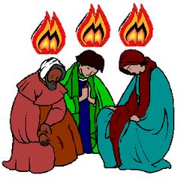
IN THE NAME OF JESUS
A Day of Healing and Empowerment

You will be empowered as a disciple of Jesus through the retelling of the Creation Story
and exploring our need for healing in order to fulfill the promise in the name of Jesus.

Presented by
FR. LEONARD WALKER
Pastor of Divine Savior Catholic Community
Parish of The National Catholic Church of North America

ALL ARE WELCOME
NOVEMBER 14TH
8:30 a.m. – 3:30 p.m.
Lunch included – Healing mass at 3:30 with open communion
Trinity Episcopal Church
365 Spring St. – Kingman, Az.

$5 contribution to cover refreshments and lunch
Register
Email: frleonard@kingmancatholic.org
Subject line: In the Name of Jesus
Message: your name and phone number
Or
Call/text
602-432-7808

